Hack the waste 2019

**THE GAME: RECYCLE RACER**

*Team: Lucky 7*

*10. may 2019*

1. INTRODUCTION

Within the Hackathon project ''Hack the Waste'' we decided to develop an easy, educational computer game for kids on the theme - recycling. The name of game is ''Recycle Racer''.

1. PROJECT SUMMARY

2.1 SITUATION OUTLINE

Earth is facing different environmental issues due to huge amounts of garbage, which is not managed in an ecological way. Air, water, groundwater and different other landscape pollution, negative impact on the animal world and our own lives - one of the ways, how to diminish the the impact of these problems is by recycling garbage, so that these materials can be reused. But as there are very different types of trash, recycling can be a difficult process especially in countries where this kind of a practise is not well developed. Even though people would like to do something about the huge amount of waste, due to their insufficient knowledge, their actions are limited.

2.3. SOLUTION and VALUE

To educate people, especially kids, on how each kind of trash should be recycled, we offer a computer game ''Recycle Racer''. We where looking at a solution that will both educate and inspire younger generations and their parents to change their behavior. We also want to raise awareness about the need of recycling with interesting facts and trough recycling gameplay. Game becomes a great educational tool for children and adults trough fun, excitement and connection.

2.4. FINANCING

As this is an Social entrepreneurship one time project the game will be offered for free for all users. To cover the developing costs we would attract a sponsorship from a waste management or an environmentally friendly company (for example, ''Getlini EKO'' ltd. in Latvia). Second potential sponsors would be Governmental institutions, like Ministry of Education and Science. This project could be sponsored also by an European Union Structural Funds or financed by larger schools, but these are less possible solutions.

The project could also be represented to B2B and B2G, but the costs are then covered by our company.

2.5. TARGET AUDIENCE

Our main target audience are kids from five to twelve years old. Old enough to be able to use different technologies, but young enough so that a simple game, like trash collecting could keep their attention. We also want to target adults from twenty-five to forty years old, because they effect on what kind of games kids can play. They could be their parents, teachers or friends. As in the game more complicated trash products would be included, adults would be able not only to educate their children, but learn themselves as well.

We can offer game to Schools or Kindergartens for educational purposes, where we directly target the main audience or on the other hand companies like some shopping malls, pastry/coffee shops, etc.

2.6. COMPETITION

We didn’t find any direct competition. But we found different other games on the same theme like: Garbage simulator, Racing games, Recycle City games etc. Some of these games pay attention to garbage collection, but some to racing and competition, but there aren't games combining these both aspects.

2.7. COMMUNICATION CHANNELS

The main platform where the game could be integrated would be the main webpage of the sponsoring entity. We had different other ideas where to offer or game, like different online gaming libraries, for example, Steam and Origin. We will mostly use the communication online to reach the target groups (social media, game review on YouTube, etc.). We can offer it to Schools or Kindergartens for educational purposes or to sponsors (companies, public organisations). Long term we can make main website and cross sell it with some other popular game like Minecraft.

1. MARKETING CAMPAIGN / STRATEGY

Marketing campaign would begin with creation of social network accounts on Instagram, Facebook, Twitter. A teaser or trailer would be prepared and launched on these social networks. After teaser period we will organize press release. To spread the word about the game, the sponsors of this project would inform their audience about the launching of the game as well. The game will be also reviewed by game influencer with a large group of potential players. For keeping our audience engaged we will keep posting different things related to the game daily.

For promotion of the game we can use interactive stands with touch screen displays, that can be positioned in public locations (libraries, shopping malls, airports, festivals, etc.) where we can directly target our audience.

* Simulation of the interactive stand with the game

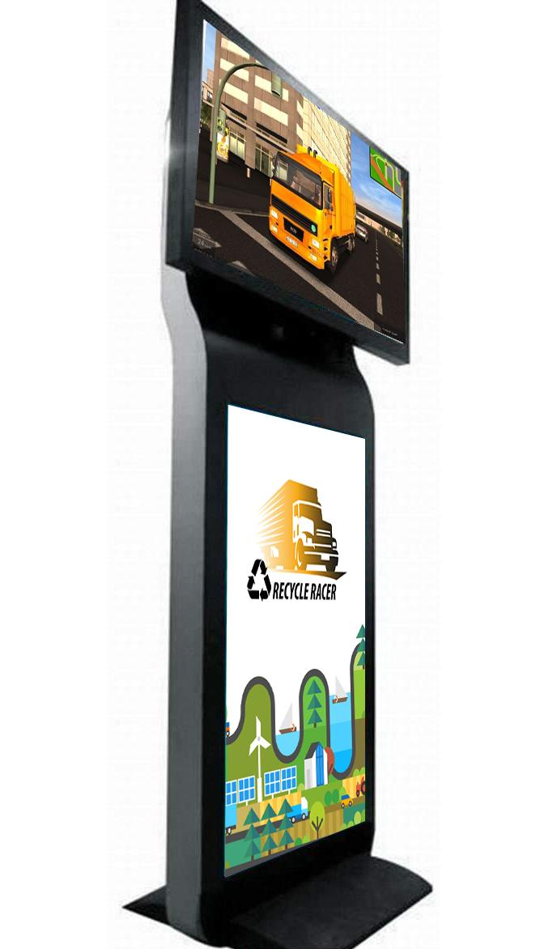

1. RESULTS - “THE GAME”

4.1. QUICK INTRODUCTION

The online game features Garbage trucks that collect different types of waste depends on their type (glass, metal, paper, plastic, organic, etc.) Focus is on collecting the right waste with the right truck, with note of the quiz and with encouraging sound inputs. The game gets harder from level to the next with introducing first simple products of waste to more difficult ones. The game can always be upgraded with new environmental themes if we decided to give it a try for long term.

4.2. VISUAL INTRODUCTION

* Logo of the game

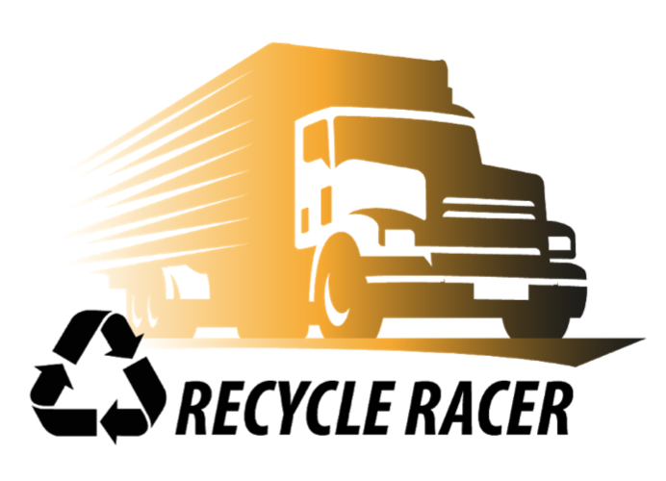

* The Game: Recycle racer

